Form SI-17 Electronic Reporting Excel Training Manual
(Unit Statistical Report)

This document is to be utilized for reporting loss data for experience modification purposes. The excel spreadsheet must be either .xls or .xlsx format. The spreadsheet can be sent via email, accompanied by contact information for the person submitting the document to Dwayne Manning (at 850-413-1784 or Dwayne.Manning@myfloridacfo.com), if you are a FSIGA (FL Self-Insurers Guaranty Association) member, your spreadsheets should be sent to FSIGA, Debra Compton (850-222-1882, or Debracompton@fsiga.org). The naming standard for the excel document will be ‘si17(your 4 digit Self-Insurance Carrier Code Number).xls(x)’, for example if your number is 1234 then the document name would be ‘si171234.xls(x)’.

An Excess Claim is a single claim for which the paid amount plus the reserves (incurred loss) is greater than $18,500, as of the Evaluation Date. These claims must be reported on an individual basis and cannot be grouped.

A Non-Excess Claim is a single claim in which the paid amount plus the reserves (incurred loss) is less than or equal to $18,500, as of the Evaluation Date. These claims must be grouped together, by injury code, class code and claim status.

For any technical assistance, please contact Ted May, at (850)413-1882. For any other questions, please contact the Dwayne Manning or Debra Compton.

You should have received the below template (Fig. 1) in a separate document for entering your data.
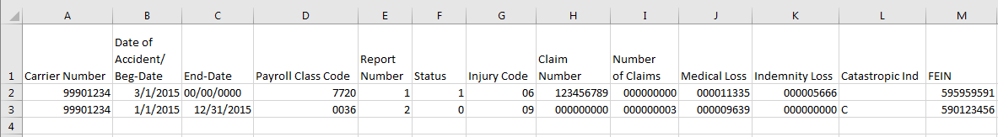Fig. 1

Formatting SI-17 Loss Data for Batch Entry
1 | Carrier Number  This is the 8-digit Division assigned Self-Insured Number.  Format: 9990NNNN Where NNNN = SI Carrier Code
2 | Date of Accident or Beginning Date  Format: MM/DD/CCYY or M/D/CCYY  Ex. 03/01/2011 or 3/1/2011  Note: If Excess Claim, enter date of accident  If Non-Excess Claim, this is the first day of the coverage reporting period
3 | Ending Date  This is the last day of the coverage reporting period corresponding to the report number.  Format: MM/DD/CCYY or M/D/CCYY  Ex. 02/28/2011 or 2/28/2011  NOTE: If Excess Claim, this field should always be zero filled or blank (00/00/0000)  If Non-Excess, this is the last day of the coverage reporting period
4 | Payroll Class Code  Up to a 4-digit payroll class code associated with a claim or group of claims being reported. Only the codes reported on FORM SI-5 (Self-Insurer Payroll Report) for the corresponding period can be utilized.  Note: If less than 4 digits sent, it will be padded with zeroes on the left side of the number prior to loading the data  Example: The number ‘36’ would be 0036
5 | Report Number  This is the period for which the report covers  Code_ Definition  1 The report covers claims for the most recent ended policy period  2 The report covers the previous period (this period would have been Report 1 at the time of the last submission)  3 The report covers the period before the previous period (this period would have been Report 2 at the time of the last submission)
6 | Status  Code Definition  0 Open Claim  1 Closed Claim
7 | Injury Code  Code Definition  01 Death  02 Permanent Total Disability  05 Temporary Injury  06 Medical Only  07 Contract Medical  09 Permanent Partial Disability (Impairment Benefits in Florida)
8 | Claim Number - For Excess Claims  Claim number assigned either by you or your servicing entity. (Up to 9-digits)  If you send less than 9 digits, the claim number will be padded with zeros on the left.  EX. If you send claim number ‘12345’ it will be entered as ‘000012345’  If Non-Excess, this field must be zero or blank
9 | Number of Claims – For Non-Excess Claims  Number of claims in the group. Non-Excess claims must be grouped by injury code, payroll classification code and status. (Up to 9-digits)  Note: Medical Incurred + Indemnity Incurred / Claim Count must be $16,000 or less  If Excess, this field must be zero or blank
10 | Medical Incurred Loss  This is the 9-digit number for the medical amount incurred for the claim. Round to the nearest whole dollar. (No dollar signs or decimals)  Ex. $9,816 in Medical Loss will be sent as 9816
11 | Indemnity Incurred Loss  This is the 9-digit number for the indemnity amount incurred for the claim. Round to the nearest whole dollar.  Ex. $7,000 in Indemnity Loss will be sent as 7000
12 | Catastrophic Indicator  This will be a BLANK, a ‘C’, or a ‘P’.
13 | FEIN  This is the Self-Insurer’s Federal Employer Identification Number.  NNNNNNNNN - Must be 9 characters Ex. 595959591

Once you have entered all data and checked it to make sure all the formatting is correct, please save your Excel document as SI17NNNN.xlsx or SI17NNNN.xls where NNNN is your Carrier Number.
Send the document to SelfInsurance.Unit@myfloridacfo.com or Fsiga@fsiga.org, if required.
Error Report
If you should receive an error report, it means that there were errors with the data that you submitted for processing and as a result, the data as a whole was rejected. The error report will list for you the record(s) number in error and it will detail the error underneath the error line. An example of the error report is provided below in Fig. 2. Please make the corrections and resend your file back to the Self Insurance Unit or FISGA, if you are required, for processing.
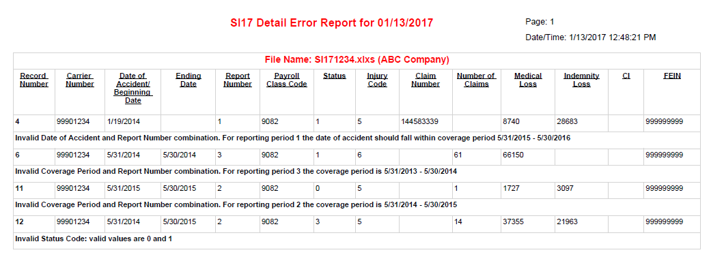
Fig. 2

