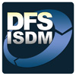
STANDARD

Web Platform Standards &

Deployment Procedures
Introduction 3
Purpose 3
Scope 3
Definitions, Acronyms, and Abbreviations 3
References 4
Menu of Services 4
Web Application Services (Mid-Range) 4
1.1 Database Services 4
1.2 File Services 4
1.3 Reporting Services 5
1.4 Job Control Services 5
1.5 Source Control Services 5
General application standards 5
Applications must be able to run on multiple application servers concurrently 5
All connectivity must use DNS instead of hard coded IP addresses 5
Code promotions must follow the guidance as outlined in sections 4 & 5 of this document 5
For Mid-Range Unix (Oracle) and Mid-Range Microsoft (MS SQL) Application Environments 6
Use Case and permissions 6
Application Servers 6
Database Services 7
File Services, Reporting Services, Job Control Services 8
Source Control Services 9
Network Considerations 9
Mid-Range Unix (Oracle) and Mid-Range Microsoft (MS SQL) Application Environment and Migration Flow 10
Source Control Procedures 11

Introduction
The goal of a shared platform for web applications is to encourage rapid development with minimal cost, high performance and a full feature set.

Purpose
The purpose of this document is to
- outline the architecture of the shared environment provided for web based applications
- outline the processes of deployment and source control for the various application platforms

Scope
This document applies to all DFS application development, including contracted application development, that will be hosted within the DFS shared web applications environment, or where systems require support from DFS infrastructure. This document describes how application changes are to be migrated on the various platforms between the DEV, TEST, STAGING/UAT and PRODUCTION Environments. Source Control guidelines are also addressed in this document.

Definitions, Acronyms, and Abbreviations
Term | Definition
Platform | DEVELOPMENT, QA, UAT/STAGING, PRODUCTION
Data Environment | Mainframe (ADABAS, DB2, IMS), Mid-range UNIX (Oracle), Mid-range Microsoft (MS SQL)
Migrate | To Copy or implement changes from one platform to another as in deploying from the DEV platform to the TEST platform or from the TEST platform to the PROD platform.
Deployment | The migration of application code changes, batch job changes and database changes, for new and existing systems into a production environment
Code | The instructions in a computer program. This includes, but is not limited to pictures, text, application scripts, compiled application code, and any other item related to application specific configuration or functionality.
Data | Information stored for use by an application. This data can be stored and retrieved from multiple sources including, but not limited to, relational databases, flat file databases, file systems or interfaces to other applications.
Firewall | A network device used to restrict network communications between network segments.
Schema | The structure defined for storing data used by an application.
Script | A pre-defined, repeatable set of steps for performing a routine task. This can be in the form of written instructions, batch scripts or automated deployment tools available within the environment.

References
Reference | Description
DIS-001 | FLAIR Applications Systems Development
DIS-002 | Program and JCL Procedures Deployment Procedures
DIS-010 | Procedures for Database Change Requests
DIS-015 | DIS Change Management Procedures
Web Deployment Procedures | Literature-for-Developers \\DFSDPLVINTP01\Literature
Rollback Scripts Repository | Where?

Menu of Services
This section narrates the application platforms that are fully supported for ongoing development within the DFS shared web system environment.

Web Application Services (Mid-Range)
- Microsoft - Internet Information Services (IIS) 7.5
- Unix - Apache Tomcat 6.0

Database Services
- Microsoft SQL Server 2008 R2
- Oracle 10g Release 2 (10.2)

File Services
- Windows 2008 R2 File Services Cluster
- Globalscape EFT Server (For FTP,FTPS,SFTP services)

Reporting Services
- Crystal Reports
- Microsoft SQL Reporting Services 2008 R2

Job Control Services
- Control M

Source Control Services
- Team Foundation Server

General application standards
In order to ensure a successful promotion there are some general guidelines that must be followed.

Applications must be able to run on multiple application servers concurrently

All connectivity must use DNS instead of hard coded IP addresses
Common DNS names: Active Directory: fldoi.gov & SMTP: smtp.fldoi.gov

Code promotions must follow the guidance as outlined in sections 4 & 5 of this document

For Mid-Range Unix (Oracle) and Mid-Range Microsoft (MS SQL) Application Environments

Use Case and permissions
Resources and Services |  | Shared Dev | Shared Test | Shared Stage | Shared Prod
Use Case |  | This environment is only for Development use. It should not be accessed by end users. | (a) This environment is primarily for Developer use; however unit testing by specific users for the purposes of Quality Assurance (QA) testing is allowed.  (b) This environment should be used to test promotion scripts for production deployments | (a) This environment is for testing the promotion of production ready code  (b) This environment can be used for full regression testing and User Acceptance Testing (UAT) | (a) This environment is for production use only.  (b) This environment is connected to production data sources
Permissions |  | "Full Privilege" developer permissions for each resource | “Limited Privilege” developer permissions for each resource | “Least Privilege” resources for each resource | “Production” privileges for each resource

Application Servers
Resources and Services |  | Shared Dev | Shared Test | Shared Stage | Shared Prod
Application Servers  (1) Microsoft IIS 7.5  (2) Unix Apache Tomcat 6.0 | Deployments | (a) Developers have full rights to promote and change code at will;  (b) Access will be granted to the OS on an as needed basisl | (a) Promotions of code and structure changes to the TEST environment are performed by the developer using scripts which the developer produces and tests in this phase  (b) Code changes can be performed at will but should be packaged for deployment to be deployed by the web server admins | (a) To promote changes to the Staging/UAT environment, an RFC or "Release" is required  (b) Code will be promoted by the app server admins  (c) Application and Web tier code is promoted by the web server admins | (a) No access will be provided for developers to the code or systems at this tier  (b) No access will be provided for developers to the database or schema at this tier  (c) Changes must pass through Change Management  (d) Code will be promoted by the web server admins
 | Rollbacks |  |  |  | A rollback file (the previous release,) is required along with the deployment file.
 | Logs |  | (a) Read access is granted to the test application log files automatically through AD  (b) Log files should be written to D:\Logfiles\appname | (a) Read access is granted to the staging application log files automatically through AD  (b) Log files should be written to D:\Logfiles\appname | (a) For internal services, read access is granted to the production application log files automatically through AD  (b) For external servers, a password is provided to the local log reader account on the external servers  (c) Log files should be written to D:\Logfiles\appname

Database Services
Resources and Services |  | Shared Dev | Shared Test | Shared Stage | Shared Prod
Database Services  (1) Oracle Databases  Dev: Names designated with a “B” suffix. i.e., DEV10B, DEV2B, DEV3B, DEV4B, DEV5B, DEV8B, DWH2B  Test: DEV10, SIEBDV (SIEBEL), DEV3 (Risk Management (STARS), DWH2, DEV4, DEV5 and DEV8.  Stage: TST10, TWH2, TST2, TST3, TST4, TST5 and TST8  Prod: PROD, DWH, PROD2, PROD3, PROD4, PROD5 and PROD8  (2) SQL Databases  Dev: DFSSQLDEV\DEV  Test: DFSSQLTEST\TST  Stage: DFSSQLUAT\UAT  Prod: DFSSQLPRD1\PRD1, DFSSQLPRD2\PRD2 and DFSSQLDIS\DIS | Deployments | Developers have full rights to modify schema and insert data at will | (a) Developers have full rights to insert data at will  (b) schema changes should be scripted | (a) Developers must request bulk data changes made directly to the application data - changes must be scripted and reversible and are performed by the Database Admins  (b) Developer must request schema changes - changes must be scripted and reversible and are performed by the Database Admins.  (c) Promotions of database objects, between TEST and STAGING/UAT, are performed by the DBAs on the Oracle and MS SQL environments | (a) Schema changes must be scripted and reversible, must pass through Change Management, and will be promoted by the database server administrators  (b) Bulk data changes made directly to the application data must be scripted and reversible, and must pass through change management, and will be performed by the Database Administrators
 | Rollbacks | A Rollback script or procedure is required for all database and application code changes | A Rollback script or procedure is required for all database and application code changes. | (a) A Rollback script or procedure is required for all database and application code changes  (b) The scripts are published to the appropriate SharePoint Site URL? for the database and web server admins | (a) A Rollback script or procedure is required for all database and application code changes  (b) The scripts are published to the appropriate SharePoint Site URL? for the databases
 | Logs | There are two logs required for the migration of code and changes at the time of staging and production. One is the RUN_ALL (execution), the other is the rollback log | There are two logs. One is the RUN_ALL (execution), the other is the rollback log. The RUN_ALL is executed first, then the rollback is executed, then the RUN_ALL is executed again | (a) On the Oracle platform the DBA sends post implementation logs to the developer for verification  (b) There are two staging logs. One is the RUN_ALL (execution), the other is the rollback log. The RUN_ALL is executed first, then the rollback is executed, then the RUN_ALL is executed again | (a) On the Oracle platform the DBA sends post implementation logs to the developer for verification on both the staging and production platforms  (b) There are two staging logs. One is the RUN_ALL (execution), the other is the rollback log. The RUN_ALL is executed first, then the rollback is executed, then the RUN_ALL is executed again  (c) On production, if all goes well, only the RUN_ALL is executed and that log is sent to the developer

File Services, Reporting Services, Job Control Services
Resources and Services |  | Shared Dev | Shared Test | Shared Stage | Shared Prod
File Services  (1) Windows 2008 R2 File Services Cluster  (2) GlobalScape EFT Server |  | Dev instances can be architected on prod if needed.
Reporting Services
(1) Crystal Reports
(2) Microsoft SQL Reporting Services
Job Control Services
Control M

Source Control Services
Resources and Services |  | Shared Dev | Shared Test | Shared Stage | Shared Prod
Source Control Services | Team Foundation Server

Network Considerations
Resources and Services |  | Shared Dev | Shared Test | Shared Stage | Shared Prod
Network Considerations |  | All development servers exist on the inside of the DFS firewall. This means that no consideration for network ports is necessary at this tier. | All Test machines exist on the inside of the DFS firewall. This means that no consideration for network ports is necessary at this tier. | (a) The application servers will be logically isolated from internal resources, such as database servers and file servers by the production DFS firewall  (b) Developers must dictate what protocol, port and destination IP the application must connect to on the DFS inside network. | (a) The application servers will be logically isolated from internal resources, such as database servers and file servers by the production DFS firewall  (b) Developers must dictate what protocol, port and destination IP the application must connect to on the DFS inside network.

Mid-Range Unix (Oracle) and Mid-Range Microsoft (MS SQL) Application Environment and Migration Flow
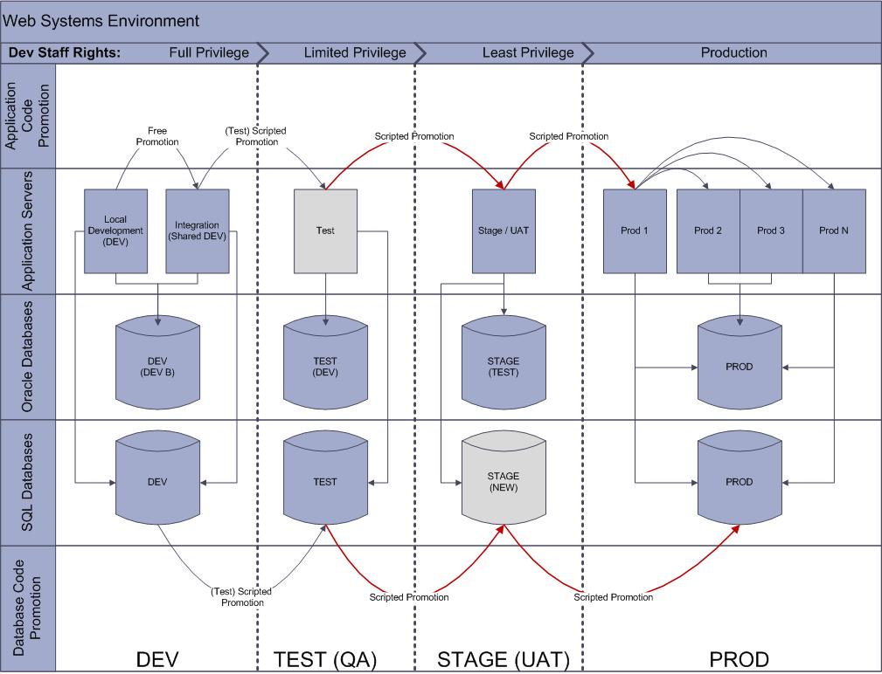Mainframe – DB2 Application Environments and Migration Flow
- There are two platforms for Mainframe and AS400 systems. They are TEST and PROD.
- For these systems, Source control relies on Production Control procedures, whereby, a library of JCL and application code is kept and maintained through procedures. Separation of duties is carried out by having the application support developer create and submit code changes to Production Control to execute.
- Adequate testing prior to executing in production is assumed in this model.
- The methods, on the Mainframe platform, for migrating code changes, are tried and true methods

DB2 Application Environment

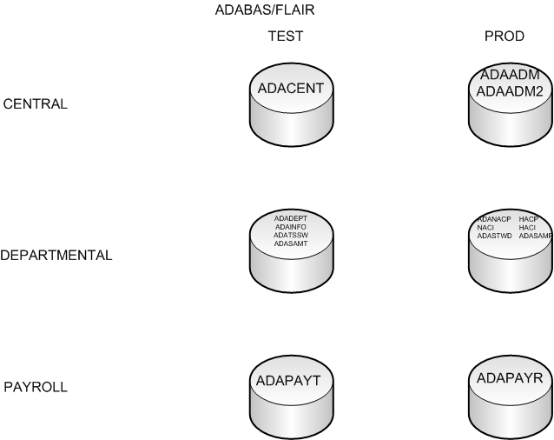

Source Control Procedures
- There are mandatory code preservation points in the migration flow for an application change.
1.) Code should be preserved at the onset of any development on existing code; 2.) When code is migrated, by the developer, from DEV to TEST;
3.) Code migrated from the TEST platform to the STAGING/UAT platform.
4.) Production code should be preserved in a production folder in TFS.

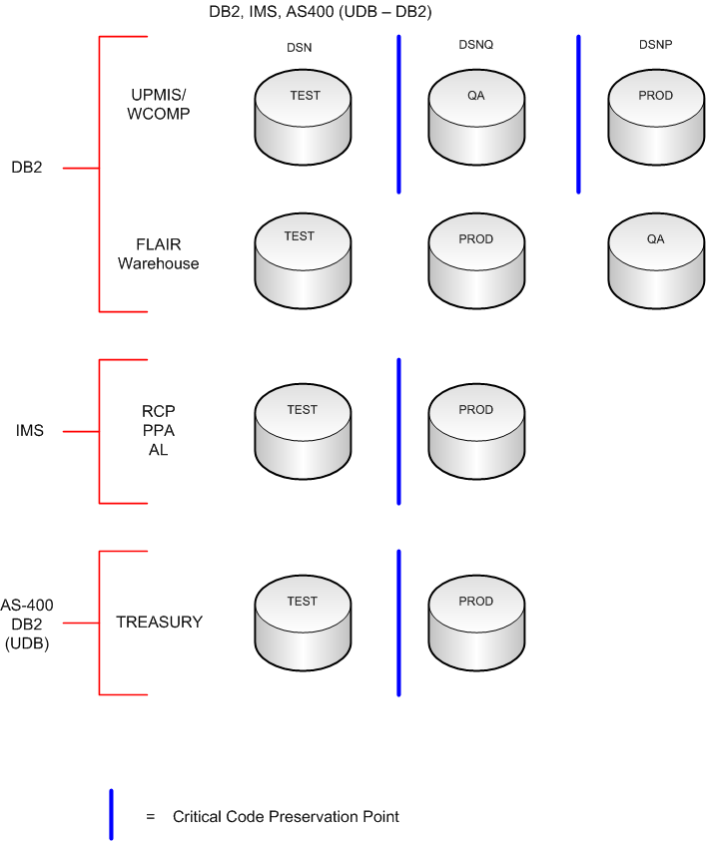
Need to add the mid-range systems critical code point preservation image

Oracle support will remain for existing applications, but is not preferred for new development

