Disinvestment Journal Line Values Job Aid
User Roles: Agency GL Journal Processor
Last Updated: 07/07/2022

This job aid is intended to assist end users in processing Disinvestment Journals in Florida PALM by providing guidance on values to be populated on journal lines.

Note: This guide MUST be edited to add your agency-specific values (e.g., Unit, SpeedType, Fund, etc.) where <enter agency value> is shown before sharing with end users.

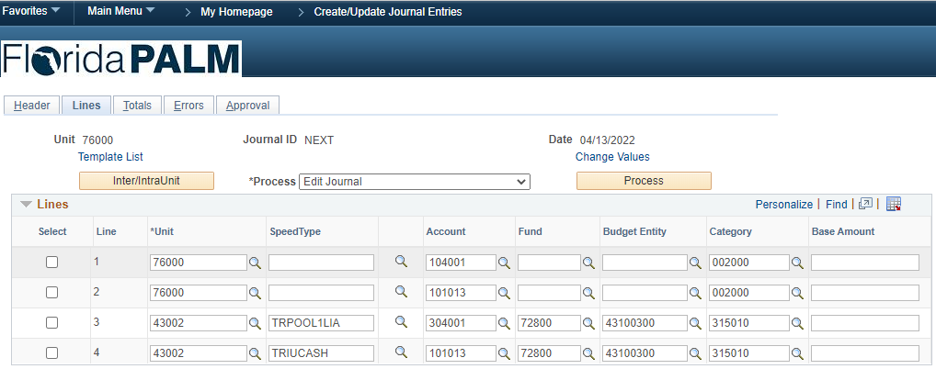
Figure 1: Florida PALM Create/Update Journal Entries Lines tab, lines section

Use the below table information to input agency-specific and treasury-specific values in the Lines section of the Lines tab of the Create/Update Journal Entries page, represented in Figure 1.

Table 1: Disinvestment Journal Line Values
Select | Line | Unit | SpeedType | Account | Fund | Budget  Entity | Category | Base  Amount
 | 1 | <enter agency value> | <enter agency value>  optional | 104001 | <enter agency value> | <enter agency value> | 002000 | Enter a negative value
 | 2 | <enter agency value> | <enter agency value>  optional | 101013 | <enter agency value> | <enter agency value> | 002000 | Enter a positive value
 | 3 | 43002 | TRPOOL1LIA | 304001 | 72800 | 43100300 | 315010 | Enter a positive value
 | 4 | 43002 | TRIUCASH | 101013 | 72800 | 43100300 | 315010 | Enter a negative value

Once Line information has been entered, continue processing the Disinvestment Journal. Click Save, Process, and then click Submit on the Approval tab, represented in Figure 1, to submit the journal for approval. If you require additional assistance, please reference the Florida PALM User Support, End User Training page.

