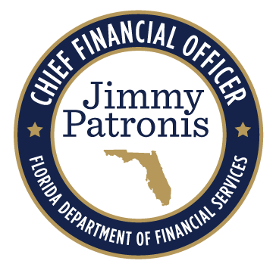
YOUR
FLORIDA PALM CCN TEAM

The DFS Change Champion Network (CCN) is a group of agency superstars here to guide you through every step leading to the implementation of Florida PALM in January 2026. The individuals listed bring forward the skills and dedication necessary to help you transition as smooth as possible.

Kim Jacobs
Training Liaison
Serves as the person responsible
for coordinating training activities within the Department.
DIFS, PAF, SFM, WC

Sheila Cole
Business Liaison
Alexandra Weimorts
Serves as the primary point of contact between the Project and the CCN.
Admin., OGC, OIT, RM, UP
Agency Liaison
Serves as the person responsible
for coordinating functional activities within the agency across business functions.

FCCS, HR, OFB, OICA

TBD
Project Management Liaison Serves as the secondary point of contact between the Project and
the CCN.
Teri Mann Business Liaison Back-up
Change Coordinator – The CCN member that has been designated as a direct contact for the division(s) identified.
Serves as the back-up person
responsible for coordinating functional activities within the agency across business functions.
Stacey Pollock
Technical Liaison
Serves as the point person for
technical activities, including security, development and testing of interfaces and conversion data, agency business system remediation, and desktop configuration activities.

Renée Hermeling
A&A Liaison
Serves as the primary point of contact between the Project and the Division of Accounting and Auditing.
A&A

David Medina Technical Application (ABS) Architect

Julia Collins-O’Kane A&A Liaison Back-up Serves as the back-up point of
contact between the Project and the Division of Accounting and Auditing.
A&A, OFR, OIR, R&L
Serves as the secondary point of
contact between OIT and the CCN.

Sarah Dugan
Treasury Liaison Serves as the primary point of contact between the Project and
the Division of Treasury.
CS, IAAS, Treasury
Michael Avello
OIT Project Management Liaison
Serves as the secondary point
of contact between OIT and the CCN.

TBD
Change Management Liaison
Serves as support to the Agency
Liaison with readiness engagement activities.

