Debt Collection Seminar

The Fair Credit Reporting Act (FCRA) is a federal law that regulates credit reporting agencies and compels them to ensure the information they gather and distribute is a fair and accurate summary of a consumer’s credit history.

(https://www.debt.org/credit/your-consumer-rights/fair-credit-reporting-act/ )

Important Links:

Florida Statutes: (http://www.leg.state.fl.us/statutes/index.cfm?App_mode=Display_Statute&URL=0500-0599/0559/Sections/0559.55.html)
- Florida Statute 17.04 – To audit and adjust accounts of officers and those indebted to the state. (http://www.leg.state.fl.us/Statutes/index.cfm?App_mode=Display_Statute&URL=0000-0099/0017/Sections/0017.04.html )
- Florida Statute 17.20 – Assignment of claims for collection.
- ( Chapter 17 Section 20 - 2022 Florida Statutes (flsenate.gov) )
- Florida Statute 95.011 – Applicability
- ( https://m.flsenate.gov/Statutes/95.011 )
- Florida Statute 95.11 – Limitations other than for the recover of real property
- ( http://www.leg.state.fl.us/Statutes/index.cfm?App_mode=Display_Statute&URL=0000-0099%2F0095%2FSections%2F0095.11.html&mf_ct_campaign=msn-feed )
- Florida Statute 222.11 – Exemption of Wages from Garnishment
- (http://www.leg.state.fl.us/Statutes/index.cfm?App_mode=Display_Statute&Search_String=&URL=0200-0299/0222/Sections/0222.11.html )
- Florida Administrative Code 69I-21 – Audit and adjustment of Accounts and recovery of Accounts receivables
- ( https://www.flrules.org/gateway/ChapterHome.asp?Chapter=69I-21 )
- 15 U.S.C CHAPTER 41 SECTION 1692 – Fair Debt Collection Practices Act
- ( https://www.ftc.gov/legal-library/browse/rules/fair-debt-collection-practices-act-text )

Florida Forms:(https://www.myfloridacfo.com/division/aa/all-forms )
- DFS-A1-1829 DFS Debt Collection Referral Form
- ( https://www.myfloridacfo.com/division/aa/state-agencies/debt-collection-program )
- DFS-A1-1950 Accounts Receivables Write-Off Form Listed under Debt Collection/Acct Rec. Write Off
- ( https://www.myfloridacfo.com/division/aa/state-agencies )
- DFS-A1-1951 Property Write-Off Form Listed under Financial Reporting
- ( https://myfloridacfo.com/division/aa/all-forms )
- DFS-A6-2095 Annual Report of Claims for Collections Form
- ( https://www.myfloridacfo.com/division/aa/state-agencies/debt-collection-program )

Reference Guide for State Expenditures:
- Pages 79-80- Settlement Claims Against the State
( https://www.djj.state.fl.us/partners-providers-staff/forms-library/procurement-and-contract-administration/reference-guide-for-state-expenditures )

Payroll Prep Manual: (https://www.myfloridacfo.com/division/aa/state-agencies/payrolls )

Memorandums:

- Chief Financial Officer Memorandum No. 14, 2022- 23 – Claims for Collections
- ( https://myfloridacfo.com/docs-sf/accounting-and-auditing-libraries/state-agencies/cfo-memos/cfo-memo-no-14---claims-for-collections.pdf?sfvrsn=139fe1a4_2 )
- Chief Financial Officer Memorandum No. 22, 2022 – 23 – Reporting Delinquent Accounts – Section 17.20, Florida Statues
- ( https://myfloridacfo.com/docs-sf/accounting-and-auditing-libraries/state-agencies/cfo-memos/cfo-memo-no-22--reporting-delinquent-accounts---section-17-20-florida-statutes.pdf?sfvrsn=75737ca5_4 )

Types of Bankruptcies:

Chapter 7 – Liquidation (4-6 Months): A trustee appointed by the court cancels many of your debts and, in some cases, may be able to eliminate all of them. A trustee will determine if you have property of value to sell before the discharge of debts.
Chapter 9 – Municipalities (3 Months – 3 Years): Financially distressed municipalities create a plan in order to repay creditors any outstanding debt. A municipality cannot liquidate their assets so bankruptcy offers them a method for repaying debts to creditors.
Chapter 11 – Large Reorganization (17 Months – 5 Years): Corporations who are suffering from financial distress continues to operate their business. However, if the court suspects fraud, dishonesty, incompetence or gross mismanagement, they may appoint a trustee to oversee the company during the proceedings. The court takes over all major decisions such as the sale of assets, lease agreements, mortgages, closing the business or entering into a modifying contract. The debtor has the exclusive right for four months after filing Chapter 11 to propose a reorganization plan, giving them the opportunity to restructure their financial situation. This may include downsizing the operation, although it could lead to liquidation of all assets.
Chapter 12 – Family Farmers (3 – 5 Years): Designed for family farmers or fishermen who may be suffering from financial distress. Debtors propose a repayment plan, making installments to creditors over a period of between three and five years. The debtor must have a regular annual income and they must be engaged in either a farming or commercial fishing operation.
Chapter 13 – Repayment Plan (3 – 5 Years): Chapter 13 of the bankruptcy code allows wage earners to discharge some or all of their debts by completing a three- to a five-year repayment plan. The debtor is protected from collections for the duration of the repayment period. The debtor has a chance to avoid foreclosure and keep your home. Chapter 13 addresses secured and unsecured debts. The debtor must repay all of his priority debts and may pay part of his nonpriority debts.
Chapter 15 – Used in Foreign Cases (3 – 5 Years): Makes legal proceedings related to an international company that is insolvent, more predictable and fair for debtors and creditors. The law is adopted from the United Nations Commission on International Trade Law’s Model Law on International Commercial Arbitration. This law reduces the risk for creditors as well as stakeholders who invest in international companies.

Exemptions & Extensions:

“If an agency determines that accounts are inappropriate for assignment to a collection agency, or if the agency determines that a different period of time for assignment is more appropriate, the agency must request an exemption from the Chief Financial Officer (CFO) in writing, unless a qualified exception applies. The exemption request for not assigning accounts to a collection agency must fully explain the nature of the delinquent accounts and the reasons why such accounts should be precluded from being assigned to a collection agency. The reason(s) must indicate that a demonstrative harm to the state will occur as a result of assignment to a collection agency. Any request for a different period of time for assignment must include an appropriate recommended period.”

Automatic Exemptions:

An agency does not need to request an exemption from the CFO* if any of the following applies:
1. Debtor has filed for bankruptcy and debt is discharged.
2. Debtor is deceased.
3. The account has reached its respective statute of limitations.
4. Debtor is actively making payments according to a payment plan agreed upon and acceptable to the agency.
5. Debtor is a department, division, agency, office, commission, board, or entity within the legislative, executive, or judicial branch of the State of Florida.
6. Debtor is a local government entity as defined in Section 218.31(1), F.S.

Contact For Exemptions/Extensions:

Please email the letter to:

Tammy Eastman, Chief
Bureau of Financial Reporting
Division of Accounting and Auditing
Department of Financial Services
FinancialReporting@myfloridacfo.com.

Debt Collection Agencies:

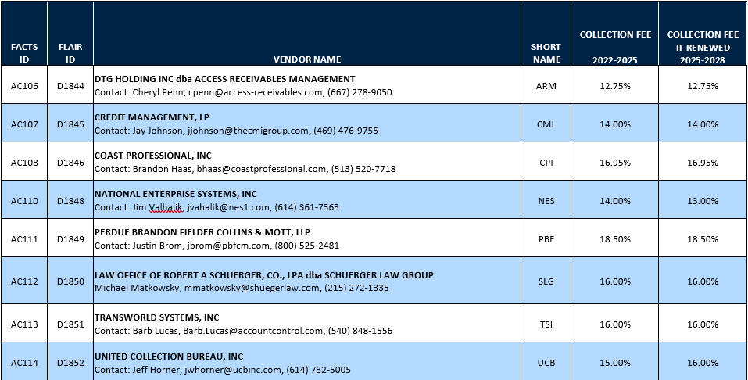

- Questions to Ask:
    - What performance metrics does your agency use to gauge in-house & referral success?
    - What is your experience with customer service? Are you having service issues?
    - We are your guidance for issues that need to be escalated.
    - What is your knowledge level with these agreements?
    - Contract feedback? Dual vs current?
    - Would you like more vendor training?
    - Have you participated in a vendor training?
    - Vendor portals?
    - Do you reconcile your data with vendor reports?
    - Would you like better reporting?

Treasury Offset Program:

The Treasury Offset Program (TOP) collects past-due (delinquent) debts (for example, child support payments) that people owe to state and federal agencies.
TOP matches people and businesses who owe delinquent debts with money that federal agencies are paying (for example, a tax refund). To the extent allowed by law, when a match happens, TOP withholds (offsets) money to pay the delinquent debt.
In fiscal year 2022, TOP recovered more than $5.2 billion in federal and state delinquent debts.
(https://www.fiscal.treasury.gov/TOP/)

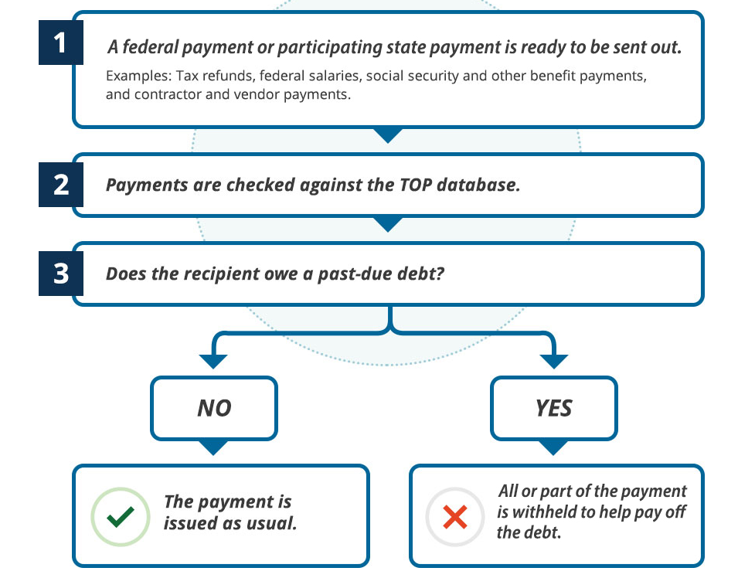

Contact Information:

Tammy Eastman
850-413-5746
Tammy.Eastman@myfloridacfo.com
Susan Sloan
850-413-5643
Susan.Sloan@myfloridacfo.com
John Herrington
850-413-5458
John.Herrington@myfloridacfo.com
Gabriel Franklin
850-413-5732
Gabriel.Franklin@myfloridacfo.com
Claims for Collections
FinancialReporting@myfloridacfo.com

